# CrowSoft’s Processes, Team and Environments (Version 1.1)

Contents

CrowSoft’s Processes, Team and Environments (Draft) 1

Introduction 1

Agile Process using Scrum 2

Sprint Planning 2

Daily Scrum 2

Sprint Reviews 2

Sprint Retrospective 2

Agile (Scrum) Key Artifacts 3

DevOps Process and Environments 4

DevOps Process 4

DevOps Environments 4

## Introduction

As we are starting as a brand new Scrum team, to successfully deliver the new CrowSoft product for developing an online system for business intelligence creating building costs and analysis according to CrowSoft’s business requirements, it will be vitally important to define our Agile and DevOps processes, setting up the team (including roles), how we will work together, what tools we need to set up our environment, to collaborate, and finally the architecture and design for our solution.

In this document, you will find an outline of the proposed Scrum process, roles required per process item, artifacts required and DevOps process and environments required

The outcome of our first spring planning meeting was as follows:

* Define overall processes for CI/CD, including what environments is required for the new CrowSoft Solution
* Define and select tools for Continuous Integration
* Define and select tools for Continuous Deployment
* Branching Structure on Github
* ***NOTE: The team was going to add more stories to this list on Jira over the weekend before the first Sprint Kick off on Monday, 4th March 2019.***

## Agile Process using Scrum

### Sprint Planning

* Hosted by Scrum Master (Alternate each week)
* Select highest priority items on Product Backlog and team turns item into Sprint Backlog
* Estimate Sprint Backlog in hours
* Work breakdown
* Declare sprint goal

### Daily Scrum

* Hosted by Scrum Master (Twice a week)
* Roles required
  + PO – Ruth Lennon
  + Scrum Master (alternate)
  + Development Team (As per Slack List for CrowSoft):
    - UX, Design, Development, QA/Testing, Delivery
* 30 Mins Standup – Monday 9:30pm, Friday 9:30am
* Not for problem solving (Let’s use Slack for problem solving)
* 3 Question:
  + What did you do?
  + What will you do?
  + What’s in your way?

### Sprint Reviews

* Hosted by Scrum Master
* After each sprint
* Accomplishments
* Whole Team present
* Demo shippable product/features

### Sprint Retrospective

* Hosted by Scrum Master
* Discuss “Start Doing”, “Continue Doing”, “Stop Doing”

Figure - Scrum Process

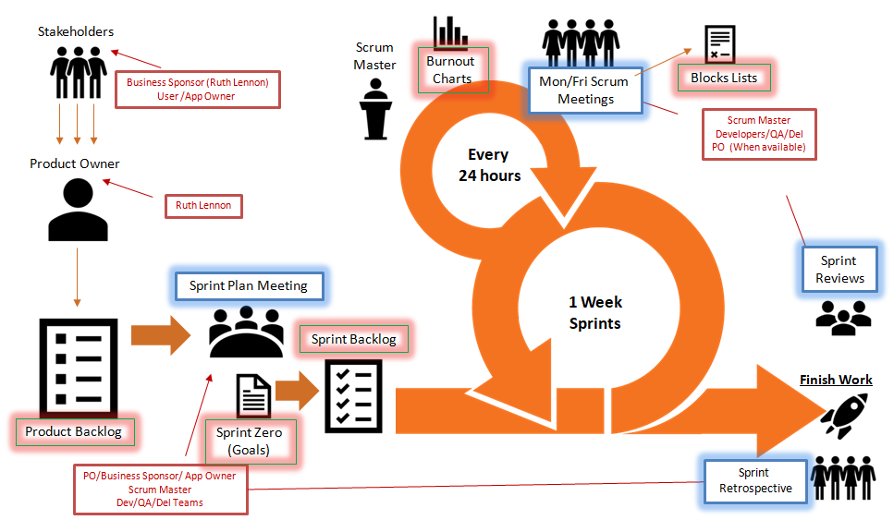

### Agile (Scrum) Key Artifacts

## DevOps Process and Environments

### DevOps Process

DevOps is a software engineering culture and practice that aims at unifying software development (Dev) and software operation (Ops).

Figure - DevOps Process

Source: : <https://en.wikipedia.org/wiki/DevOps>

### DevOps Environments

We need to select tools and environments to be configured for the following areas:

* Plan
  + Requirements & Planning (Jira, Slack, Blackboard, Zoom)
  + Architecture & Design (Draw.io)
* Build
  + Language tools (Visual Studio Code or Visual Studio Community 2017)
  + Unit Testing (Nunit)
  + Source Control (Git, GitHub)
  + Automated Testing (Selenium)
* Continuous Integration (Jenkins)
* Deploy
  + Configuration Management (Nuget, Ansible)
  + Artifact Management (jFrog Atrifactory)
  + Deployment Environments (Linux Ubuntu 16.04)
* Operate
  + Operate and Monitor (Monit)
* Continuous Feedback (Slack, Jira, Zoom, Blackboard)